**

**Certificate of Participation**

This certificate is awarded to Mr. **Estefano Muñoz** for his participation in the exhibition **MOLLUSCA, ESPIRAL DEL CAMBIO** as supporting staff on the effects of climate change on the shell material of calcifying mollusks.

This exhibition is part of the outreach activities performed under the project “CarboNat Lab” PIA ANILLOS ANID ACT172037 and was held at the **Natural History Museum of Valparaiso (MHNV)**, Chile.

On September 12 - October 12, 2019

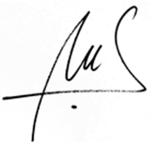

Dr. Nelson A. Lagos

Director Centro de Investigación e Innovación para el Cambio Climático (CiiCC)

CarboNat Lab project